**Booked BV**

**URS**

**Name:** Steven Chen

**Class:** S2-CB02

**Date:** 14-05-2023

**Version:** 1.3

**Contents**

**1.** **Agreement with client** 3

**2.** **Functional requirements** 4

**Desktop application:** 4

**Web application:** 5

**3.** **Use cases** 6

**Desktop application** 6

**Web application** 10

**4.** **GUI** 16

**Wireframes** 16

**Desktop application** 20

**Web application** 24

# **Agreement with client**

During the meetings with the client (John Smith), we discussed about the necessity that the company wants and ask question to the client on how he want the product to look like.   
In the meetings the client told us that the main priority is to get a website where client can book a flight or hotel and a desktop application to manage them.

Therefore we have decided upon for the entire semester to work on these 2 application as the main priority. Additional feature to improve the application could be added if there is enough time, but the main feature will be the priority. The main features of these application will be further explained in this document and the uses of them.

# **Functional requirements**

For these applications there are 2 actors which consist of the clients which here is referred to as the “User” and the administration where they add content to the website which is referred to in these functional requirements and Use Cases as the “Admin”.

## **Desktop application:**

**ID: D-FR-01**

Name: Admin can view all bookings

**ID: D-FR-02**

Name: Admin can view all Users

**ID: D-FR-03**

Name: Admin can view all Hotels

**ID: D-FR-04**

Name: Admin can view all Flights

**ID: D-FR-05**

Name: Admin can add a new flight for the website

**ID: D-FR-06**

Name: Admin can add a new hotel for the website

**ID: D-FR-07**

Name: Admin can delete a flight from the website

**ID: D-FR-08**

Name: Admin can delete a hotel from the website

**ID: D-FR-09**

Name: Admin can update/change a flight from the website

**ID: D-FR-10**

Name: Admin can update/change a hotel from the website

**ID: D-FR-11**

Name: Search/filter user, flight, hotel, and booking

## **Web application:**

**ID: W-FR-01**

Name: User can log in

**ID: W-FR-02**

Name: User can make an account

**ID: W-FR-03**

Name: User can change their personal information

**ID: W-FR-04**

Name: User can search/filter for hotels

**ID: W-FR-05**

Name: User can search/filter for flights

**ID: W-FR-06**

Name: User can book a hotel

**ID: W-FR-07**

Name: The website calculates the price based on the number of days of the hotel

**ID: W-FR-08**

Name: User can book a flight

**ID: W-FR-09**

Name: The website calculates the price based on the seats and baggage on the flight.

**ID: W-FR-10**

Name: User can see a history of all bookings made

**ID: W-FR-11**

Name: User can view details of the booking

**ID: W-FR-12**

Name: User can add a review on a hotel

**ID: W-FR-13**

Name: User can edit their own review

**ID: W-FR-14**

Name: User can delete their own review

# **Use cases**

**Desktop application:**

**ID: UC-01 (D-FR-01, D-FR-02, D-FR-03, D-FR-04)**

Use Case: Displaying a list of every booking/user/hotels/flights

Actor: Admin

Main Success Scenario:

1. Admin clicks on "Bookings"  
2. Admin sees a list of all the bookings

Extensions:  
1a. Admin clicks on Users  
 2. Admin sees a list of all Users  
1b. Admin clicks on Hotels  
 2. Admin sees a list of all Hotels

1c. Admin clicks on Flights  
 2. Admin sees a list of all Flights

**ID: UC-02 (D-FR-05)**

Use Case: Add flight to the website

Actor: Admin

Main Success Scenario:

1. Admin clicks the "Add flights”  
2. Admin fills in the details of the flight that is going to be added to system.  
3. Flight has been added to the website

Extensions:  
3a. Any required field details are missing

1. Displays a message about field is missing  
2. Return MSS 2

**ID: UC-03 (D-FR-06)**

Use Case: Add hotel to the website

Actor: Admin

Main Success Scenario:

1. Admin clicks the "Add hotel”  
2. Admin fills in the details of the hotel that is going to be added to system.  
3. Hotel has been added to the website

Extensions:  
3a. Any required field details are missing

1. Displays a message about field is missing  
2. Return MSS 2

**ID: UC-04 (D-FR-07)**

Use Case: Remove flight from website

Actor: Admin

Main Success Scenario:

1. Select a flight from the list
2. Admin clicks the Remove button
3. System shows a warning message about confirming the removal of the content
   1. Trigger: Confirm removal is triggered
4. Selected flight is removed

Extensions:

3a. No content is selected

1. System displays a message about no flight is selected
2. End of use case

4a. Selected 'Cancel' on warning message about confirming the removal

1. System displays that removal has been cancelled
2. Return MSS 2

**ID: UC-05 (D-FR-08)**

Use Case: Remove hotel from website

Actor: Admin

Main Success Scenario:

1. Select a hotel from the list
2. Admin clicks the Remove button
3. System shows a warning message about confirming the removal of the content
   1. Trigger: Confirm removal is triggered
4. Selected booking is removed

Extensions:

3a. No content is selected

1. System displays a message about no hotel is selected
2. End of use case

4a. Selected 'Cancel' on warning message about confirming the removal

1. System displays that removal has been cancelled
2. Return MSS 2

**ID: UC-06 (D-FR-09)**

Use Case: Update the flight content

Actor: Admin

Main Success Scenario:

1. Select a flight from the list/DataGrid
2. Admin clicks the Update button
3. Admin makes changes
4. Content is updated

Extensions:

3a. No content is selected

1. System displays a message about no flight is selected
2. End of use case

4a. Field is empty when changes are made

1. System displays message that a field is empty
2. Return MSS 3

**ID: UC-07 (D-FR-10)**

Use Case: Update the hotel content

Actor: Admin

Main Success Scenario:

1. Select a hotel from the list/DataGrid
2. Admin clicks the Update button
3. Admin makes changes
4. Content is updated

Extensions:

3a. No content is selected

1. System displays a message about no flight is selected
2. End of use case

4a. Field is empty when changes are made

1. System displays message that a field is empty
2. Return MSS 3

**ID: UC-08 (D-FR-11)**

Use Case: Search for hotel/flight/user/booking

Actor: Admin

Main Success Scenario:

1. User writes the name of the content (hotel/flight/user/booking)
2. Click on the “Search button”
3. Display the content

Extensions:

3a. No content is found

1. Display nothing on the grid/list

**Web application:**

**ID: UC-09 (W-FR-01)**

Use Case: User can log in

Actor: User

Main Success Scenario:

1. User click on the log in button in the Login page
2. User fills in the email and password
3. User goes back to home page and is logged in

Extensions:

3a. Wrong credentials

1. User gets informed that the credential is wrong
2. Return MSS 2

**ID: UC-10 (W-FR-02)**

Use Case: User make account

Actor: User

Main Success Scenario:

1. User goes click “Create an account” link in login page
2. User goes to the register page
3. User fills in personal information
4. User goes back to home page, the account is created and user is logged in

Extensions:

3a. Any required details of the user is missing

1. Displays a message about user detail is missing
2. Return MSS 3

**ID: UC-11 (W-FR-03)**

Use Case: User changes personal information

Actor: User

Main Success Scenario:

*Precondition: User must be logged in and User could cancel with a button any time.

1. User goes to their personal page
2. Click personal information tab
3. User click change personal information
4. User writes changes
5. Personal information has been changed

Extensions:

5a. Any field is missing

1. Displays a message about field is missing
2. Return MSS 4

**ID: UC-12 (W-FR-04)**

Use Case: User can search/filter for hotels

Actor: User

Main Success Scenario:

1. User search for a hotels based on Name/City/Country
2. User can sort by A-Z, Z-A, Price low to high, Price high to low
3. Click on search button
4. Content will be shown

Extensions:

3a. If there is no content that matches the search

1. Displays a No hotels found
2. Return MSS 1

**ID: UC-13 (W-FR-05)**

Use Case: User can search for flight

Actor: User

Main Success Scenario:

1. User pick a departure country and a arrival country
2. Clicks on search button
3. Content will be shown

Extensions:

3a. If there is no content that matches the search

1. Displays a No Flights found
2. Return MSS 1

**ID: UC-14 (W-FR-04, W-FR-06, W-FR-07)**

Use Case: User book hotel process

Actor: User

Main Success Scenario:

*Precondition: User must be logged in

1. User search for a hotels
2. Click on search button
3. Content will be shown
4. User select a content
5. User goes to the details page
6. User select a start and end date and click “Book now” button
7. Goes to a payment page and sees the total price that is calculated based on the input
8. User click pay now
9. User goes to home page and display a message saying booking is booked

Extensions:

7a. If the date input are empty or incorrect

1. User stay in the same page
2. Displays a message about the dates are wrong
3. Return MSS 6

**ID: UC-15 (W-FR-05, W-FR-08, W-FR-09)**

Use Case: User book flight process

Actor: User

Main Success Scenario:

*Precondition: User must be logged in

1. User search for a flights
2. Click on search button
3. Content will be shown
4. User select a content
5. User goes to the details page
6. User select a start date, end date, and if extra luggage or not and click “Book now” button
7. Goes to a payment page and sees the total price which is calculated based on the input
8. User click pay now
9. User goes to home page and display a message saying booking is booked

Extensions:

7a. If the date input are empty or incorrect

1. User stay in the same page
2. Displays a message about the dates are wrong
3. Return MSS 6

**ID: UC-16 (W-FR-10, W-FR-11)**

Use Case: User view all booking history and details

Actor: User

Main Success Scenario:

*Precondition: User must be logged in and User could cancel with a button any time.

1. User goes to their personal page
2. See a list of all the booking made
3. User click on “See booking details”
4. User goes to the details page of the booking

**ID: UC-17 (W-FR-12)**

Use Case: User can add reviews on hotels

Actor: User

Main Success Scenario:

*Precondition: User must be logged in.

1. User select a content
2. User goes to the detailed page of the hotel
3. User can write a review and give rating on the page
4. Click the add review button
5. Review is added

Extensions:

5a. Any required field is missing

1. Displays a message about field is missing
2. Return MSS 2

**ID: UC-18 (W-FR-13)**

Use Case: User can edit reviews on hotels

Actor: User

Main Success Scenario:

*Precondition: User must be logged in.

1. User select a content
2. User goes to the detailed page of the hotel
3. User sees all the reviews that are made and click on the Edit button
4. User makes changes and clicks Save
5. Review is changed

Extensions:

5a. Any required field is missing

1. Displays a message about field is missing
2. Return MSS 3

**ID: UC-19 (W-FR-14)**

Use Case: User can delete reviews on hotels

Actor: User

Main Success Scenario:

*Precondition: User must be logged in.

1. User select a content
2. User goes to the detailed page of the hotel
3. User sees all the reviews that are made and click on the Edit button
4. User clicks on the Delete button
5. Review is deleted

# **GUI**

**Wireframes:**

**Home page**

**Hotel page**

**Detailed hotel page**

**Flight page**

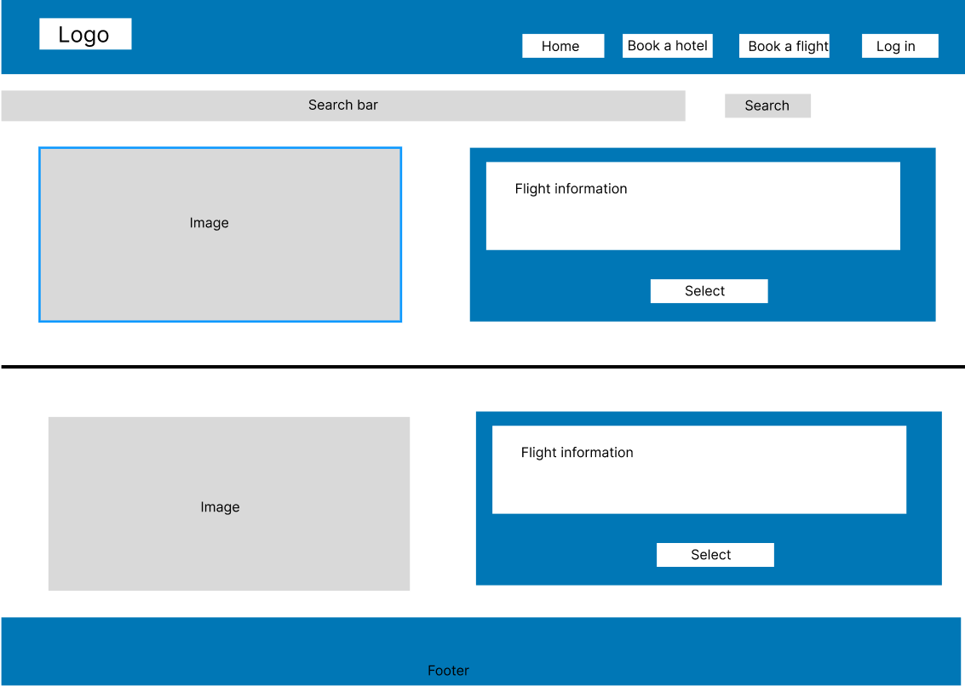

**Detailed flight page**

**Log in page**

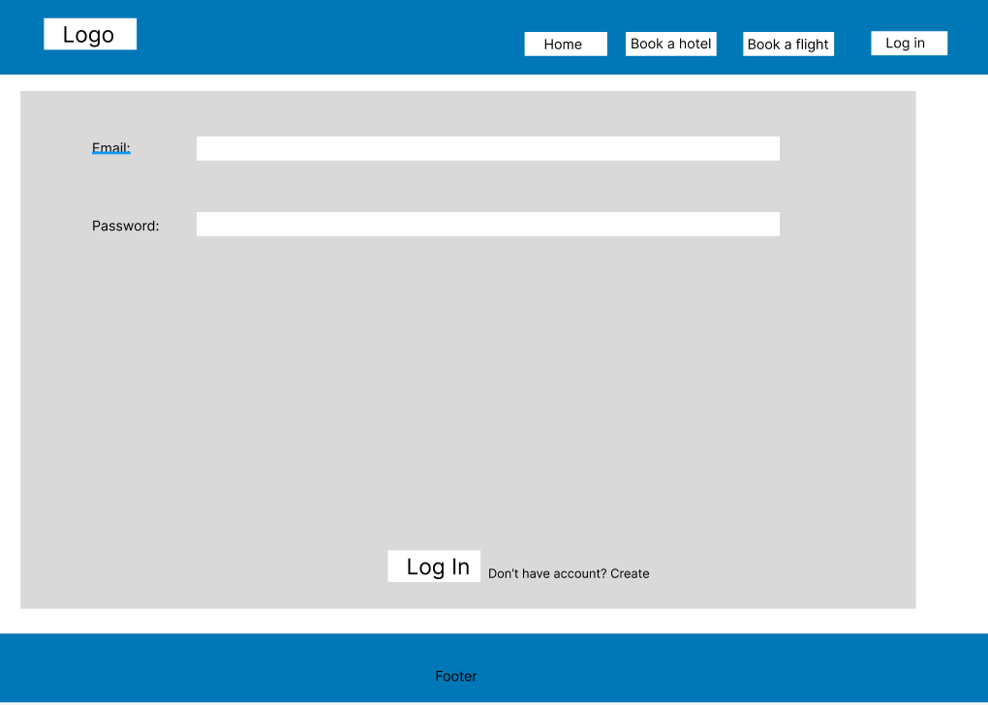

**Sign up page**

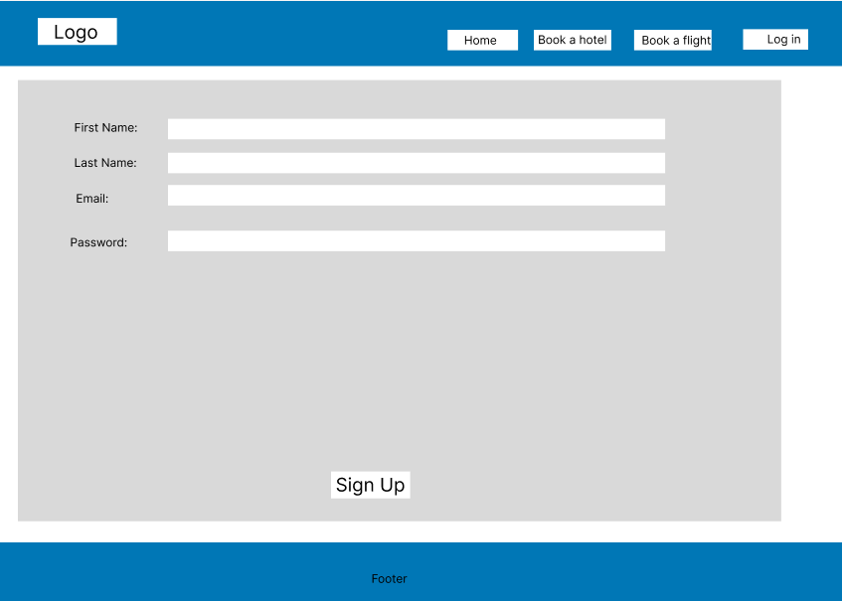

**Desktop application:**

**Main form:**

**Hotel section:**

**Add hotel:**

**Update hotel**

**Flight section:**

**Add flight:**

**Update flight:**

**Web application:**

**Home page**

**Hotel page**

**Hotel details page:**

**Flight page**

**Flight detail page:**

**Login page:**

**Register page:**

**User personal page:**

